На 19.03.2020 г.
1. Отправить на адрес электронной почты (kudrina.ana@yandex.ru), выполненное домашнее задание (упр. 22 стр. 181 из учебника английского языка для моряков).
2. Прочитайте диалоги. Откройте скобки и поставьте глаголы в одном из времен Indefinite Passive.
1. A: Where the Tretyakov Gallery (to be situated)?
B: It (to be situated) not far from Tretyakovskaya Underground Station.
A: What pictures (to be displayed) in it?
B: The Tretyakov Gallery is famous for its wonderful collection of pictures by the best Russian painters.
2. A: Is there a port in Moscow?
B: Yes, there is. Moscow (to be situated) on the Moskva River and has big modern ports.
A: Moscow (to be visited) by river ships only?
B: Oh, no. Moscow ports (to be visited) by sea-going ships too.

3. A: Are there many sports facilities in Moscow?
B: Yes, there are. Many of them (to be built) for the XXII Olimpic Games which took place in Moscow?
A: Any new stadiums, gyms and swimming-pools (to be built) in the near future?
B: I think many new sports facilities (to be constructed) in the near future.

3. Переведите диалоги (письменно).
4. Письменно выполните упражнение 2.
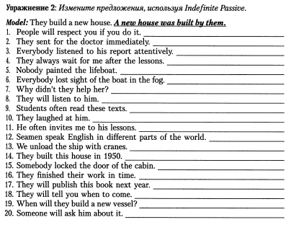
Выполненные задания отправить на почту kudrina.ana@yandex.ru не позднее 25.03.2020 г.

